**Tourist places in ayodhya :**

**1.Hanuman Garhi :**

When Lord Rama returned to Ayodhya after getting victory over Ravana, Hanumanji started living here. That is why it was named Hanumangarh or Hanuman Kot. It was from here that Hanumanji used to protect Ramkot. In the main temple, Pawansut sits on the lap of Mata Anjani.Located in Ayodhya, it is one of the most important temples in the city along with other temples like Nageshwar Nath and the under-construction Ram temple.

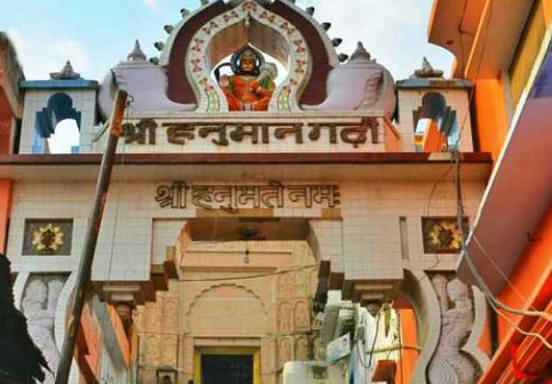

**2. Kanak Bhawan**

Kanak Bhawan is to the north-east of Ram Janam Bhumi, Ramkot, in Ayodhya. Kanak Bhawan is one of the finest and famous temples in Ayodhya and is a must visit. It is believed that this Bhawan was gifted to Devi Sita by Kaikei immediately after her marriage to Lord Ram. This is private palace of Devi Sita and Lord Rama. Vikramaditya got it renovated. Later it was rebuilt/renovated by Vrish Bhanu Kunwari which exists even today. The main idols installed in the garbhgrih (sanctum), are of Lord Ram and Devi Sita.

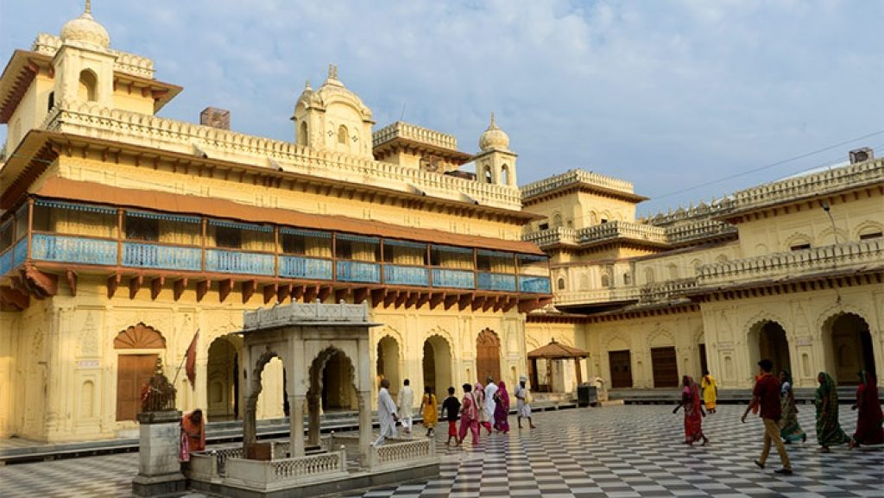

# 3. Guptar Ghat

# At a distance of 10 km from Ayodhya Junction, Guptar Ghat is a holy ghat situated on the banks of River Saryu in Faizabad near Ayodhya. It is one of the popular religious places to visit in Ayodhya. Guptar Ghat holds immense religious significance. According to legend, Guptar Ghat is believed to be the place where Lord Rama meditated and undertook the Jal Samadhi to leave the earth and go back to his original abode 'Vaikunta'. It is a popular belief among devotees that taking a dip in the Saryu river on this ghat will wash away their sins and relieve them from worldly worries. The ghat resounds with the chants of Lord Rama's name as devotees and priests sing hymns in his praises.

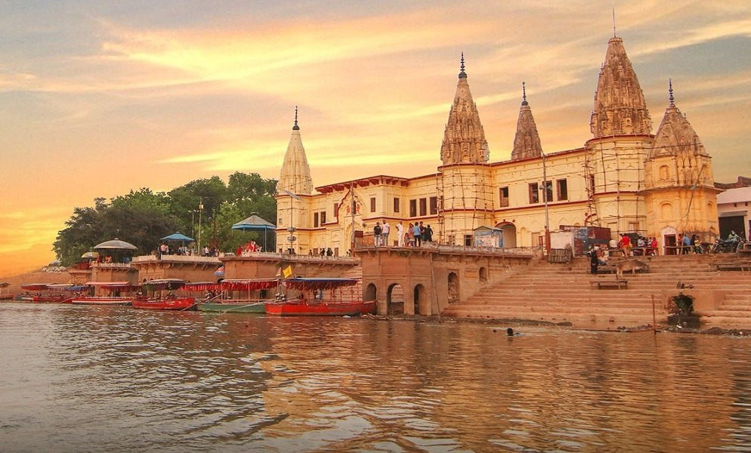

**2. Varanasi :**

# Sarnath

The Dhamekha stupa and other imposing structures adorn this holy site where Buddha first preached his message.

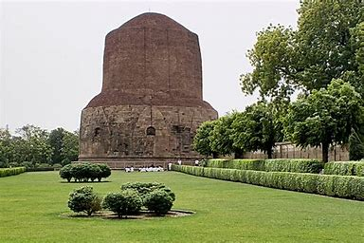

**Banaras Ghats**

One of the oldest cities of India, Banaras acts as an important religious center. The numerous bathing ghats (steps) along the bank of the Ganges attract huge crowds of pilgrims.

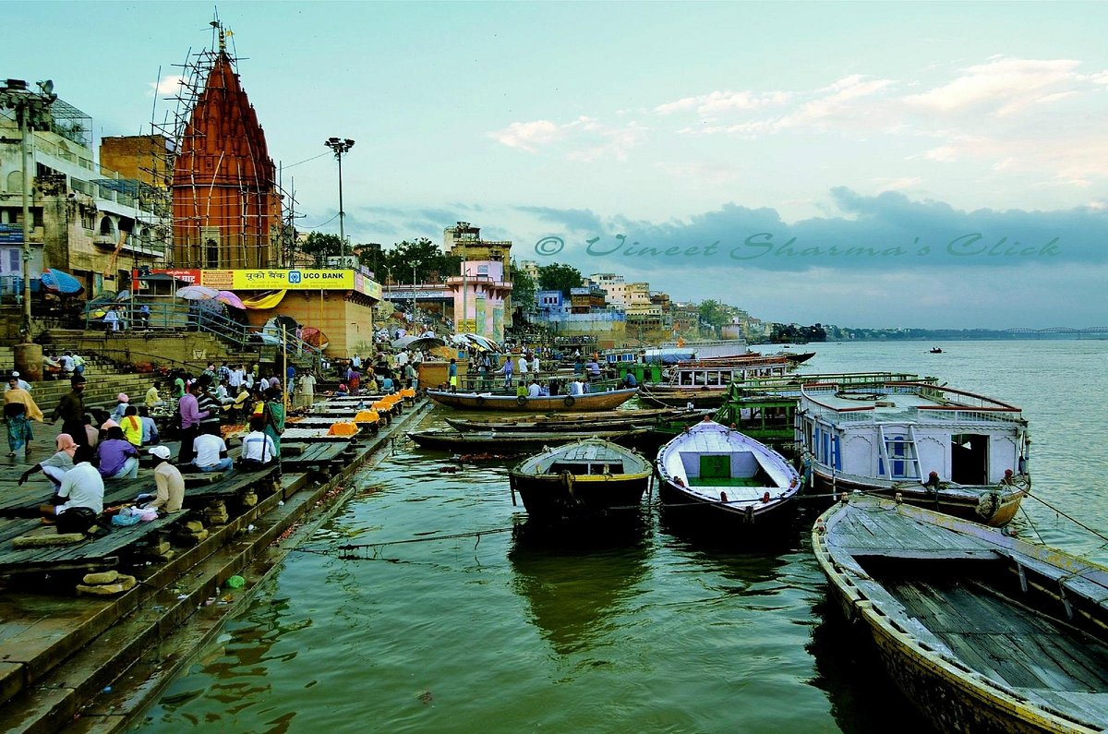

# Durga Temple(Monkey temple)

# Durga temple is also known as the Monkey temple (because of the presence of huge number of monkeys), situated in the Durga Kund, Varanasi. The temple is dedicated to the Goddess Durga. It was built in the 18th century. Durga temple was constructed by a Bengali Maharani in the north Indian Style with multi tiered shikhara. An attractive pond known as the Durga Kund is made on the right side of the temple which really increases the beauty of the temple. The pond has stone stairs at all sides as well as there is watch pillars at each corner of the pond.

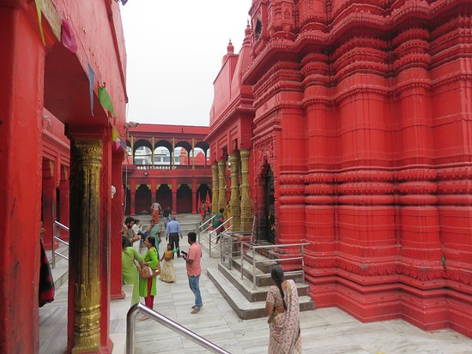

**3. Jammu Vaishanvo devi temple (Katra):**

## **Patnitop Tourism**

Patnitop, nestled in the Udhampur district of [Jammu & Kashmir](https://www.holidify.com/state/jammu-and-kashmir/), is a charming hill station that captivates visitors with its serene landscapes and captivating beauty. Situated at an elevation of approximately 2,024 meters, Patnitop offers a tranquil escape from the hustle and bustle of city life. Known for its lush green meadows, dense forests, and panoramic views of the surrounding mountains, Patnitop is a popular destination for nature lovers, families, and those seeking a peaceful retreat

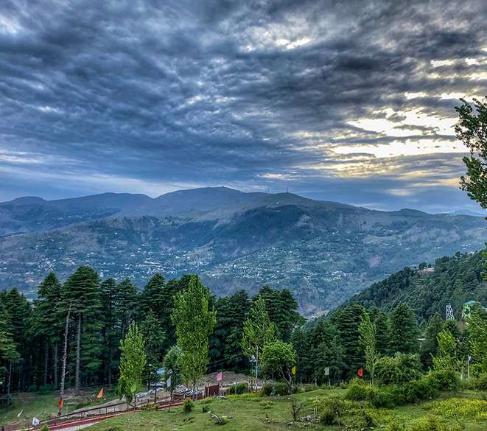

# Shivkhori

Shivkhori, a divine shrine of an avatar of Lord Shiva, is located in the lap of nature in the form of a cave on a hillock in Udhampur district in India's own Heaven on Earth, Jammu and Kashmir. The 4-foot lingam was formed naturally in a cave. This self-manifested lingam of Lord Shiva is also known as Swayambhu and is of great importance in Hindu religion. According to some, the cave is dedicated to one of the forms of Lord Shiva, which is believed to be unborn and invisible. As one explores the cave, they experience the divine aura of this form of Lord Shiva. Shivkhori is an enchanting destination famous for its religious belief. The route inside the cave is challenging for many, and the thrill is worth experiencing as devotees are sure to feel blessed at the sight of the idol.

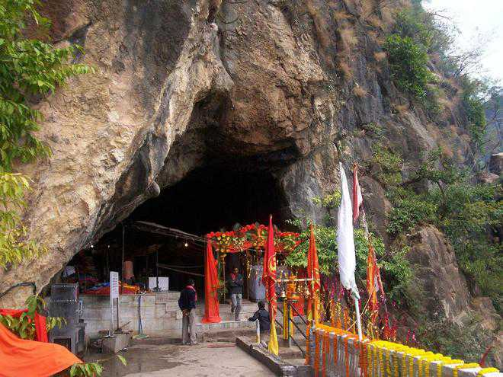

# BAGH E BAHU

Bagh-e-Bahu is a famous terraced garden built around the Bahu Fort in the city of Jammu. This picturesque garden is characterized by sparkling waterfalls, sprawling lawns, artificial lake, attractive flower beds, appealing fountains and trees. It is situated 5 km away from Jammu city center on the left bank of Tawi River. Bahu fort is the oldest fort in Jammu city, was originally built by Raja Bahu Lochan over 3000 years ago. Inside, there is a temple dedicated to the Hindu goddess Kali. It is a favorite picnic spots for the locals and tourists alike. Mini buses and auto-rickshaws are the common modes of the transportation to reach the Bahu Fort and Bagh-e-Bahu Garden.

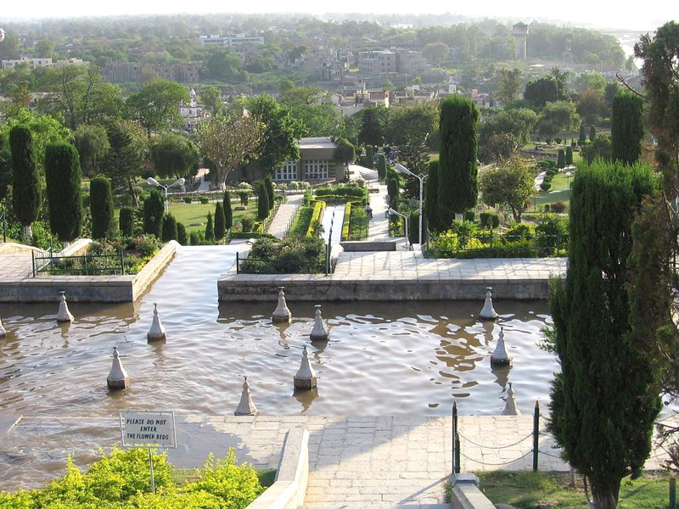

**4.Kedarnath**

## **Shankaracharya Samadhi**

Located just behind the revered Kedarnath Temple lies the sacred resting place of Adi Shankaracharya, the eminent saint credited with establishing the four sacred dhams in India, integral to Hindu pilgrimage. This renowned Hindu philosopher achieved nirvana at a remarkably young age of 32 and, according to legend, merged with the very land he tread upon. The Shankaracharya Samadhi in Kedarnath, drawing pilgrims in the thousands, stands as a significant tourist attraction.

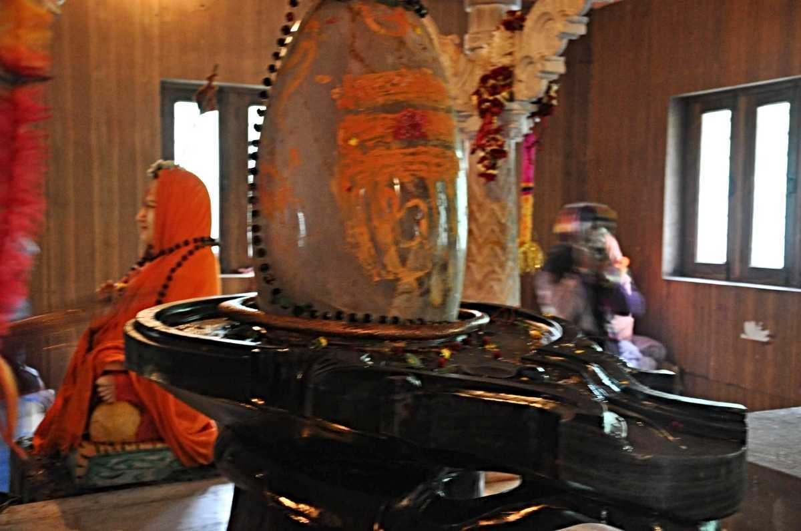

## **Bhairavnath Temple**

Situated at a distance of 500 m from the Kedarnath Temple on the southern side, Bhairavnath Temple is enshrined by the revered Hindu God - Lord Bhairav. It is perched on top of a hillock and offers magnificent views of the surrounding Himalayas and the entire Kedarnath valley below. Lord Bhairav is believed to be the main gana of Lord Shiva and hence the temple is all the more important. The enshrining deity of the temple is also known as Kshetrapal or the guardian of the region, has a Trishul for a weapon and a dog as his vehicle

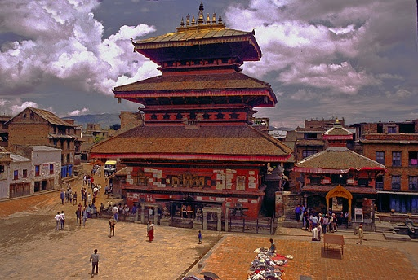

**Sonprayag**

Sonprayag, situated in the Rudraprayag district of Uttarakhand, India, holds profound religious significance as it marks the sacred confluence of two mighty rivers, Basuki and Mandakini. Nestled amidst the picturesque Himalayan landscape, this tranquil hamlet serves as a pivotal point for pilgrims embarking on the sacred Char Dham Yatra, which includes the revered shrines of Kedarnath and Badrinath.

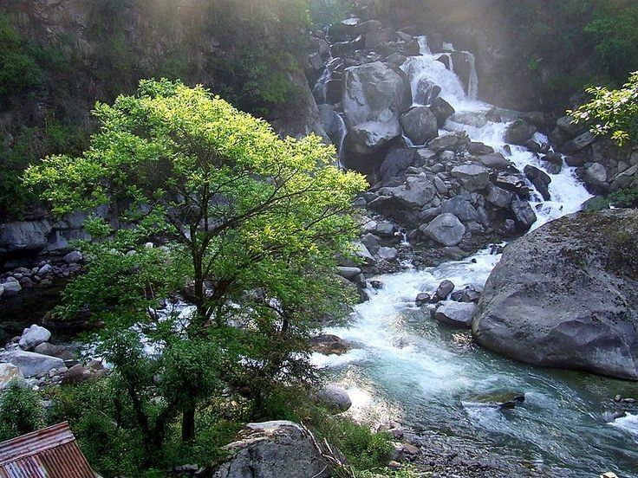

**5. Badrinath**

## **Vasudhara Falls**

The nectar sweet, Vasudhara Falls surging near the holy city of Badrinath is one of the most enchanting places to visit in Uttarakhand. This ravishing waterfall drops from a height of 400 feet about 122 metres above sea level. People believe that the heavenly beauty of the Vasudhara falls can only be savoured by those who are clean, pure and unstained from guilt. Although, it is a remote destination but the undiluted beauty and cool ambiance of this waterfall tempt the nature worshippers to visit it.

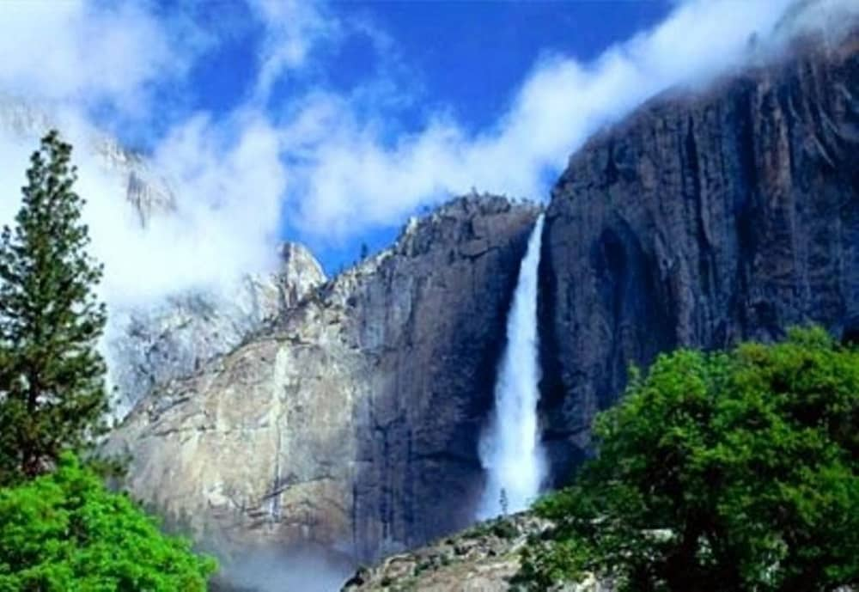

# Alka Puri

# Alkapuri is the source of river [Alaknanda river](https://www.euttaranchal.com/uttarakhand/alaknanda-river). It is situated at the base of Balakun peak at 4,600 metres above sea level near[Badrinath](https://www.euttaranchal.com/tourism/badrinath.php) in [Chamoli district](https://www.euttaranchal.com/uttarakhand/chamoli) of Uttarakhand.

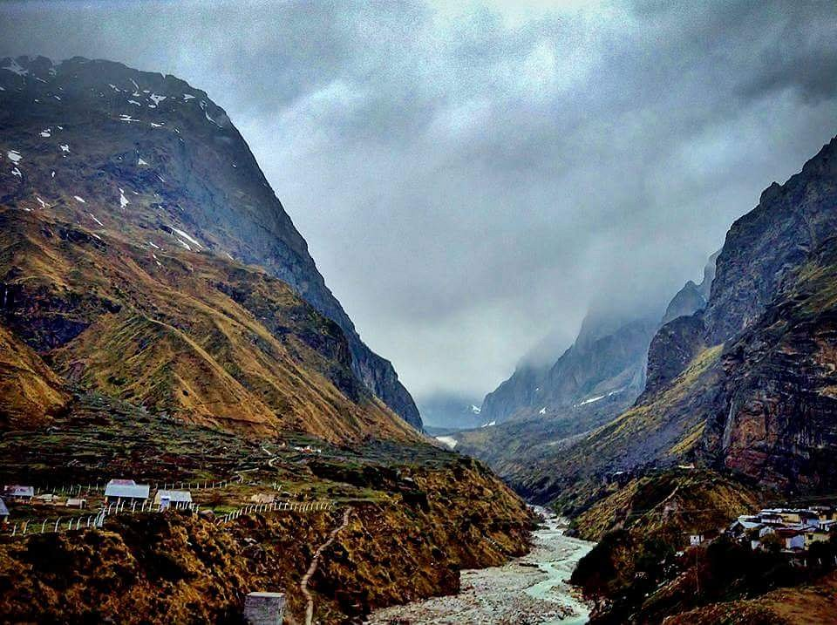

**Brahma Kapal**

Situated on the banks of Alaknanda River, Brahma Kapal is a place in [Badrinath](https://www.euttaranchal.com/tourism/badrinath.php) which is of great importance for Hindus. It is here they pay homage to the dead souls of their ancestors. This place is located around two kilometers far from the hills of Badrinath

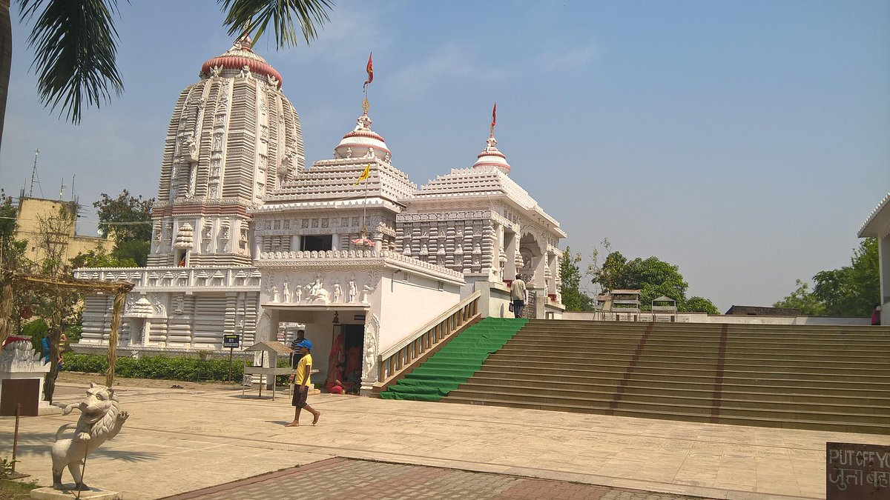

**6. Madurai :**

## Thirupparankundram Murugan Temple

* **Famous for:** Hinduism, Architecture, Murugan.
* **Tickets:** Entry free.
* **Opening Timings:**Open all days from 5:30AM–1PM & 4PM–9PM
* **Duration:**2 hours.

**Thirupparankundram** gains importance as it is one of the six places chosen by god Murugan as his abode. It is said that this was where Lord Murugan married Devasena. It is also considered as the place where sun and moon abide. This cave temple is dedicated to the element of earth among the five elements and various Tamil classical texts mention this hill as ‘Southern Himalaya’. It might interest you to learn that the hill not only houses Murugan temple but also an Islamic Shrine, which is dedicated to Sekunder. The architecture is amazing.

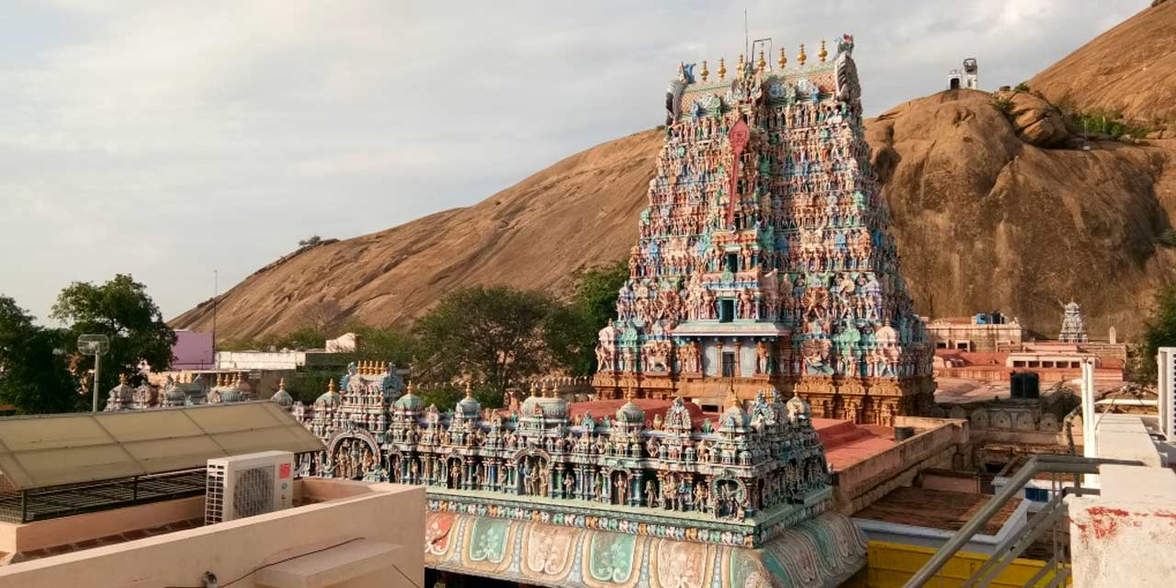

## **Gandhi Museum**

* **Famous for:** History, Gandhi, Freedom struggle.
* **Tickets:** No entry fee.
* **Opening Timings:**Open all days from 10AM–1PM & 2PM–5:45PM.
* **Duration:**1 hour.

Gandhiji and Madurai share a bond. It was after his visit to Madurai that Gandhi changed his dress code, which he followed until he met his end. **Gandhi Museum** was constructed in memory of Gandhiji after his assassination. The building, which houses the museum, was constructed around 1670 AD by Nayak Queen Rani. The construction was completed and inaugurated in 1959. The museum houses a Picture Gallery, which presents Gandhiji’s visual biography. The history of Freedom struggle is depicted with 265 illustrations in the Special Exhibition section. The ‘Hall of Relics’ preserves some original and replicas of Gandhi’s personal belongings. Cultural programmes are conducted in the open air theatre here, which can accommodate 8000 people. The library in Gandhi Museum has a vast collection detailing India’s cultural background and books by Gandhiji.

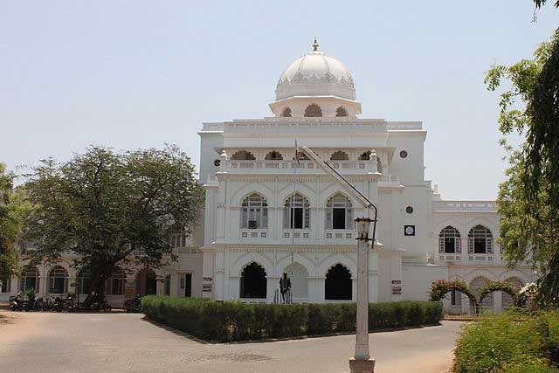

## **Pazhamudhir Solai**

* **Famous for:** Hinduism, Architecture, Murugan.
* **Tickets:** No entry free.
* **Opening Timings:**Open all days from 5:30 AM – 1PM & 4PM – 9PM.
* **Duration:**2 hours.

This is yet another famous temple dedicated to Lord Murugan and it is located on hill top. It is considered as one amongst the six abodes of god Murugan. The sculptures carved of marble and wood are unique. The giant steps in front of the temple make for a great climb. It is one of the most beautiful temples in South India.

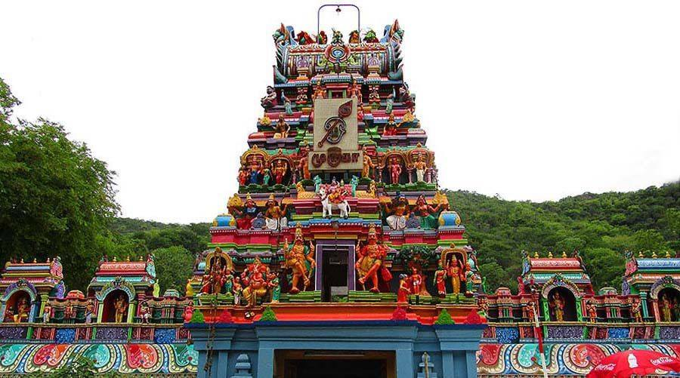

**7. Ooty:**

# Nilgiri Mountain Railway

Nilgiri Mountain Railway, also known as Toy Train in Ooty, is one of the key attractions of the popular hill station Ooty. Such is the train's popularity and history that it was declared as a World Heritage Site by UNESCO in 2005. Started in the year 1899, it has continued to charm its visitors over the past many years winding its way through the best of nature.

The Toy Train covers a distance of total 46 km in a span of 5 hours and takes one through a truly spectacular journey filled with picturesque views en route. Another fascinating feature of the train is that its youngest X-class locomotive is over 50 years old and the oldest is 80 years old.

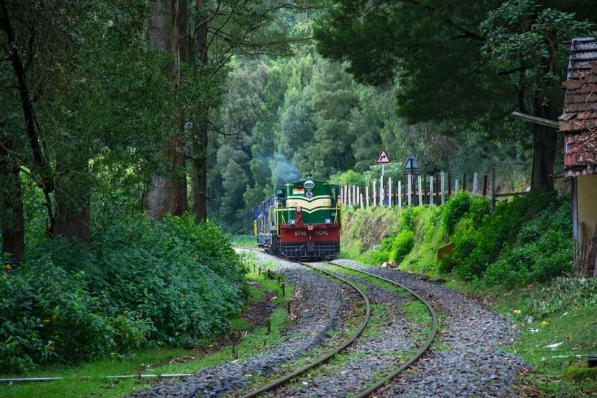

# Emerald Lake, Ooty

Emerald Lake is situated in Emerald Village, around 20-22 kilometres from the main city of Ooty and is a part of the Silent Valley National Park in the Nilgiris District. Serene and away from the maddening crowd, the lake and its surroundings are much cleaner and offer a perfect place to enjoy a leisurely time in the vicinity of nature and quietude.

It is one of the unexplored and virgin places of the South Indian hill station, not yet encroached by the masses of tourists that visit the place every year. Emerald Lake is the ideal spot in Ooty for nature lovers.

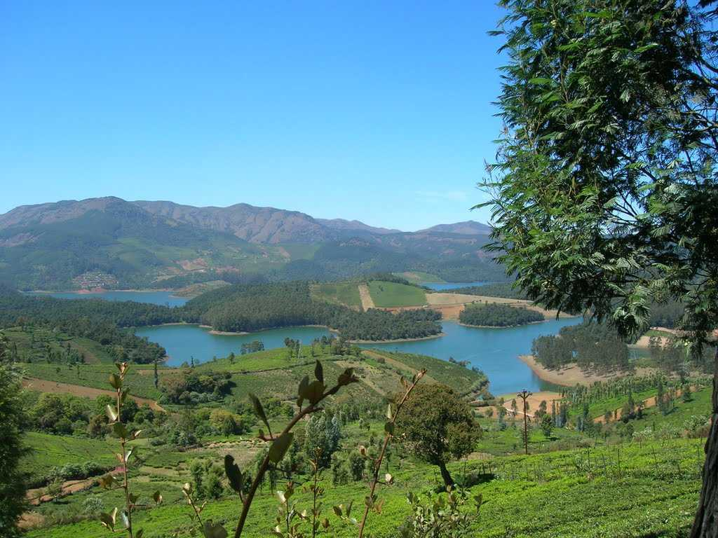

## **Dolphin's Nose, Ooty Overview**

Located about 12 km away from Coonoor is the Dolphin's Nose about 1,500 meters above sea level. The tip of the peak of this enormous rock resembles a dolphin's nose and this is one of the most visited tourist spots in The Nilgiris District of Tamil Nadu.

It is set amidst the rolling hills of the Nilgiris Hills (or the Blue Mountains). The gigantic rock formation is entirely unprecedented. There are enormous canyons found on both the sides of the destination and there is a clear view of the Catherine Falls, another popular tourist destination with its ongoing current several thousand meters below, which is located at a short distance from the Dolphin's Nose

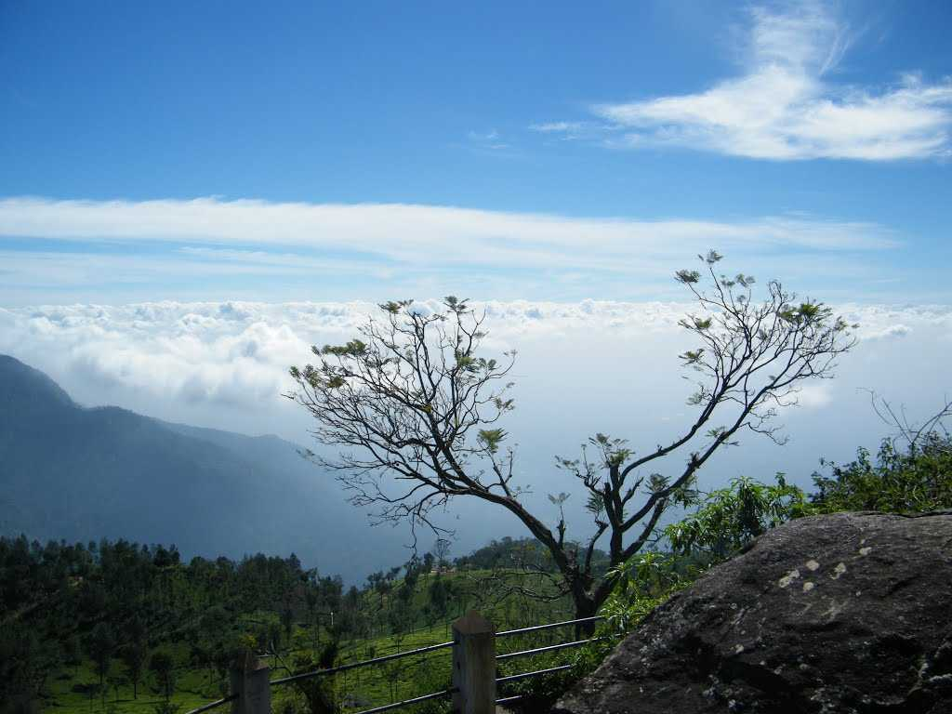

**8. Dwaraka**

# Sudama Setu

# Sudama Setu Bridge is a stunning suspension bridge built for pedestrians to cross River Gomti. The bridge was named after Sudhama, Lord Krishna's childhood friend. It was inaugurated by Anandiben Patel, the CM of Gujarat in 2016.

# Sudhama Setu connects the ancient Jagat Temple and the sacred Panchkui Teerth on the island which is associated with the legendary Pandava brothers. Besides mythology, the bridge is also famous for a breathtaking view of the river and the Arabian Sea. There are ample seating arrangements here to enjoy the view.

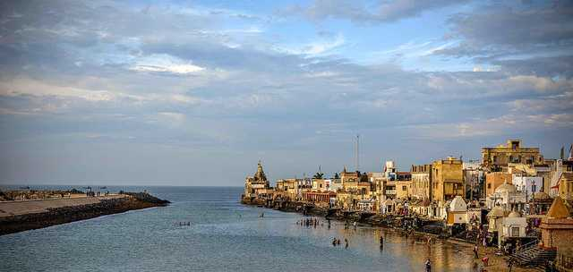

# Nageshwar Jyotirlinga

Nageshwar Temple situated in Dwarka is one of the 12 Jyotirlingas in India. It is located on the route between Gomati Dwarka and the Bait Dwarka Island on the coast of Saurashtra in Gujarat. Also sometimes known as Nagnath Temple, the main deity here is Lord Shiva, also known as Nageshwar Mahadev. According to the Shiva Purana, those who pray at the Nageshwar Jyotirlinga become free from all poisons, snake bites and worldly attractions.

Unlike other Nageshwar Temples, the statue or the Linga here faces south. A major highlight of Nageshwar Temple is the massive 80 feet tall statue of Lord Shiva. The temple itself is characterised by typical Hindu architecture. The Nageshwar Shiva Linga is made up of stone, known as Dwarka Shila, having small chakras on it. It is in the shape of 3 mukhi Rudraksha.

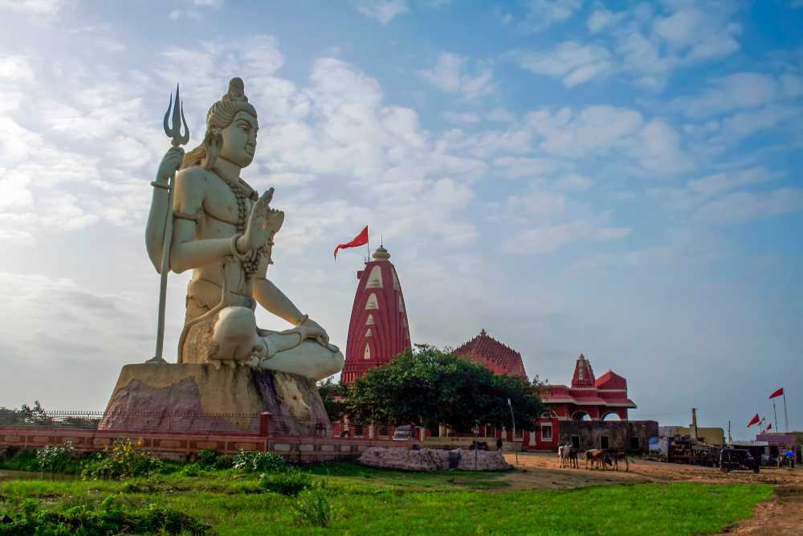

# Rukmini Devi Temple

An ancient tale of separation, the Rukhmini Devi Temple is located about 1.5 km from the Dwarka city centre. This 12th-century remnant carries out some evident architectural marvels of the time through its mural carvings and other structures.The Hindu mythical story behind this temple begins with Rukhmini Devi and her husband Lord Krishna, picking up the sage Durvesha for dinner. On the way, Rukhmini Devi stopped to quench her thirst at the Ganges, with the help of her husband.Known to be short-tempered, Durvesha Muni was quite enraged when she did not offer him any water. Thus he summoned Rukhmini Devi to be separated from Lord Krishna. Therefore, her temple lies at the outskirts, while Lord Krishna's temple is within the Dwarka city.

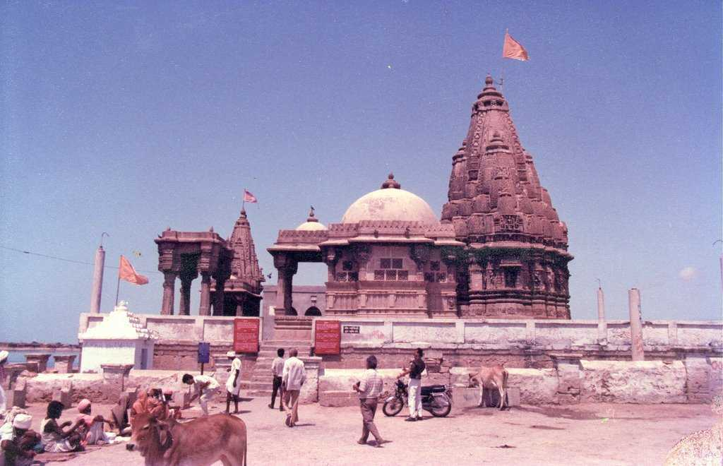

**9. Shirdi**

# Shani Shingnapur

Shani Shignapur Temple is a Jeet Devasthan (alive temple) in Ahmednagar district, well-known for the magical and powerful Lord Shani, who is believed to reside in a black stone till date. The Hindu God symbolising the planet Saturn is referred to as Swayambhu, which means that he has emerged himself in the form of the black stone that scores lakhs of devotees every year. The trust of people in the lord is so strong that none of the houses in the wondrous village has doors and locks as people believe that Lord Shani is protecting their valuables from thieves.

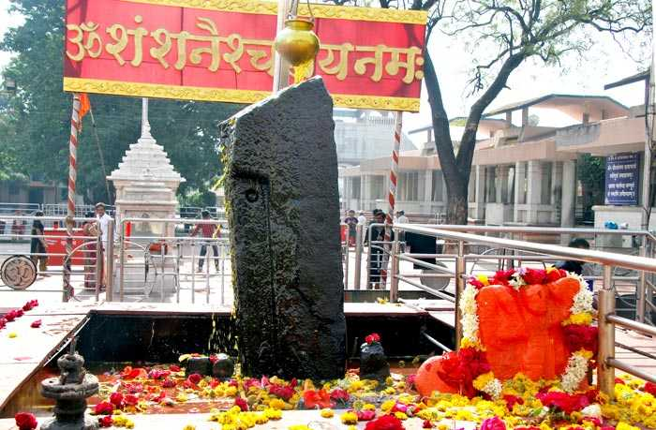

# Wet n Joy Waterpark

Although most famous for its shrine dedicated to Sai Baba, Shirdi also houses the Shirdi Water Park. This destination has a number of thrilling rides and activities which are equally enjoyable for children and adults alike. Located about 5 kilometres away from Shirdi in Nighoj Village, this destination is a much-needed respite from the heat and is a fun filled way to spend some time with near and dear ones.

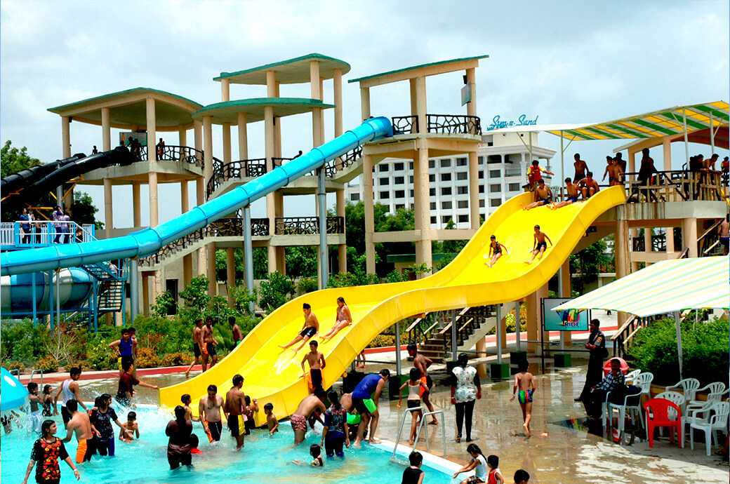

**10. TIRUPATI**

**Kapila Theertham**

Located at a stone's throw distance of 4 Km from Tirupati Kapila Theertham is a fascinating waterfall at the base of the Seshadri Hills. Glistening white waters plunging down a height of 100 metres to form a pool inside the premises of the Kapileshwar Temple is a spectacle to witness. Kapeela Theertham is the main temple of Lord Shiva in Tirupati in which the Shiva Lingam is made of metal.

As you enter the sanctum of the temple you will be awestruck to see the massive stone effigy of Nandi- Lord Shiva’s bull. Kapila Theertham is visited by a large number of followers on special occasions like Annabhishekam, Maha Shivaratri, Vinayaga Chaturthi and Brahmotsavam. Among these festivals Kapileswara Swamy Brahmotsavam is the most significant one which is celebrated throughout the span of February.

**Best time to visit**: During the rainy season between November- February.  
**Timings**: Timings of visit are from 5 a.m. to 8:15 p.m. everyday.

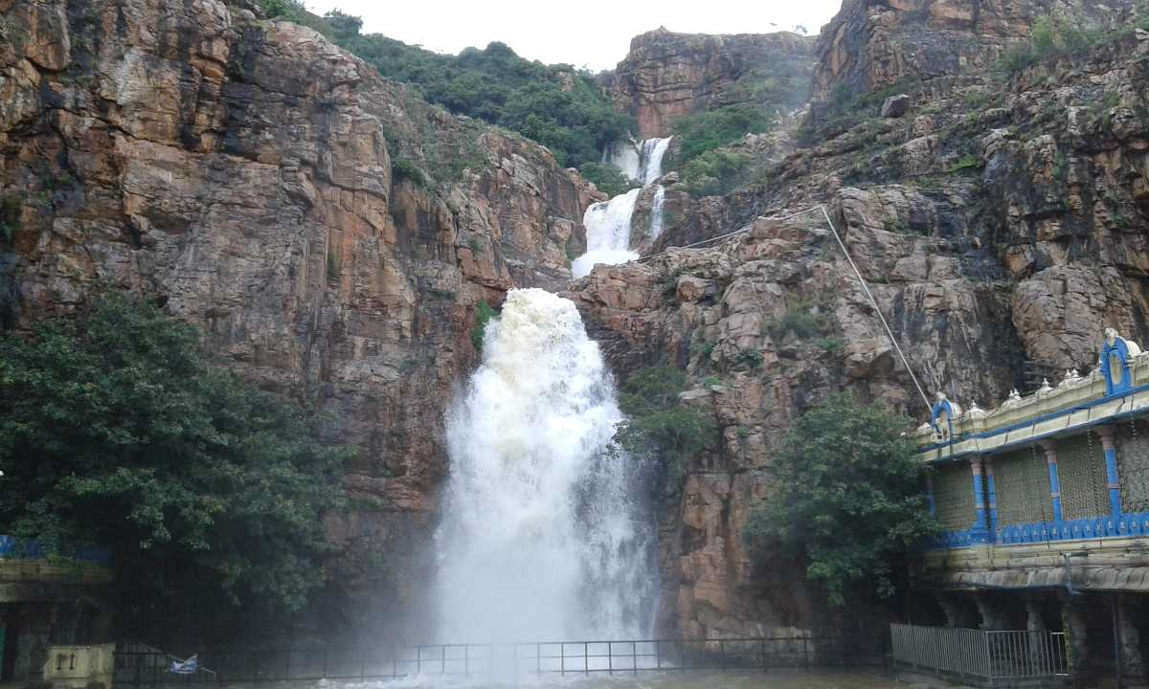

**Regional Science Centre Overview**

The world of science welcomes you with a massive planetarium with activity oriented informal science education, sky observation deck and galleries hosting science exhibitions and shows for school children. It is one of the top places to see in Tirupati which organises experience based educational programmes for all aged visitors.   
  
The Regional Science Centre Tirupati (RSCT) has 6 permanent exhibition galleries namely Fun Science, Our Senses, Popular Science, Illusion and Emerging Technology and Our Universe. It also hosts an outdoor science park spreading over an area of 5 acres. The outdoor park of RSCT houses exhibition halls, herbal garden, prehistoric life park and an animal corner. The regional Science Centre Tirupati is an autonomous unit under the Ministry of Culture, Government of India and is directly run by the Visvesvaraya Industrial and Technological Museum Bangalore.  
  
**Best time to visit**: Any time of the year.  
**Timings**: Between 10am -6pm.   
**Price**: Entry fees are INR 25 (Science Centre), INR 10 (shows), INR 25 (3D film shows) and INR 30 (Planetarium)  
**Location**: Planetarium Road, Tirupati,  Andhra Pradesh- 517507

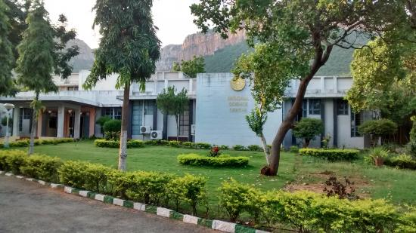

**Sri Padmavathi Ammavari Temple**

Located at a distance of just 5 kilometres from Tirupati Sri Padmavathi Ammavari Temple is one of the must visit places in Tirupati. It is also known by the name of Alamelu Mangapuram Temple. It is believed that goddess Padmavati descended on a golden lotus in this place.  
  
Hence the temple got its name derived (‘alar’- lotus, ‘mel'- top, ‘manga’- goddess and ‘puram'- village). There are several other folk tales surrounding this temple which makes it a highly revered place to see in Tirupati.   
  
**Best time to visit**: Although it is flocked by the followers throughout the year, the best time to visit the Padmavathi Ammavari Temple is during the festivals such as

Navaratri, Theppotsavam, Kartheeka and Dussehra.  
**Timings**: The temple timings are from 5:00 am- 9:00 pm everyday.  
**Location**: Sannidhi St, Tiruchanur, Tirupati,  Andhra Pradesh- 517504

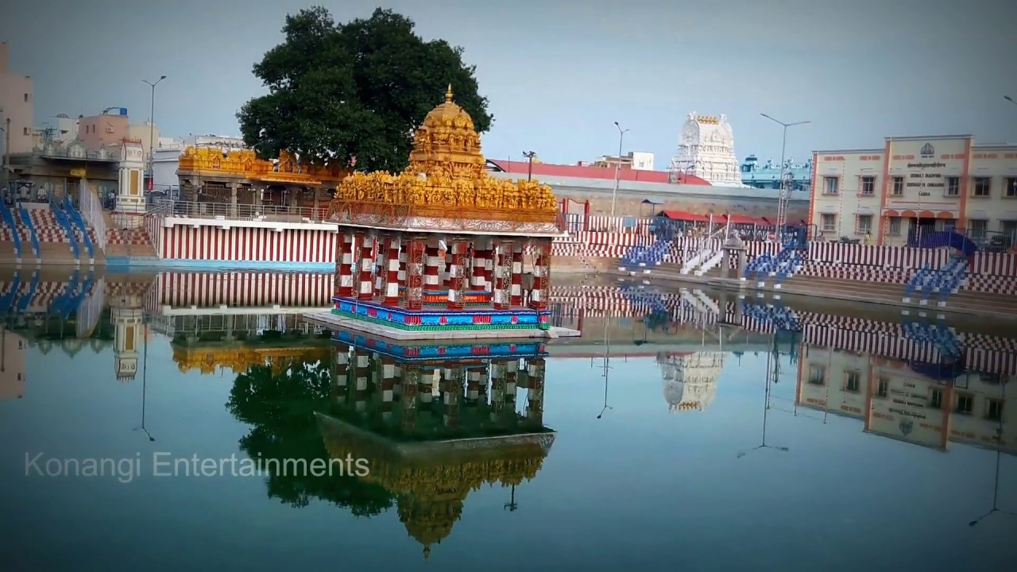

**11. Goa**

# Dudhsagar Falls

One of India's tallest waterfalls, the Dudhsagar Falls is located inside the Mollem National Park. The majestic falls are a little farther inland approximately 60 km from Panaji on the Goa - Karnataka Border. Literally translating to *Sea of Milk*, the 310 m high waterfall is divided into four tiers on the Mandovi river and resemble a heavy rush of milk flowing effortlessly down the hill.

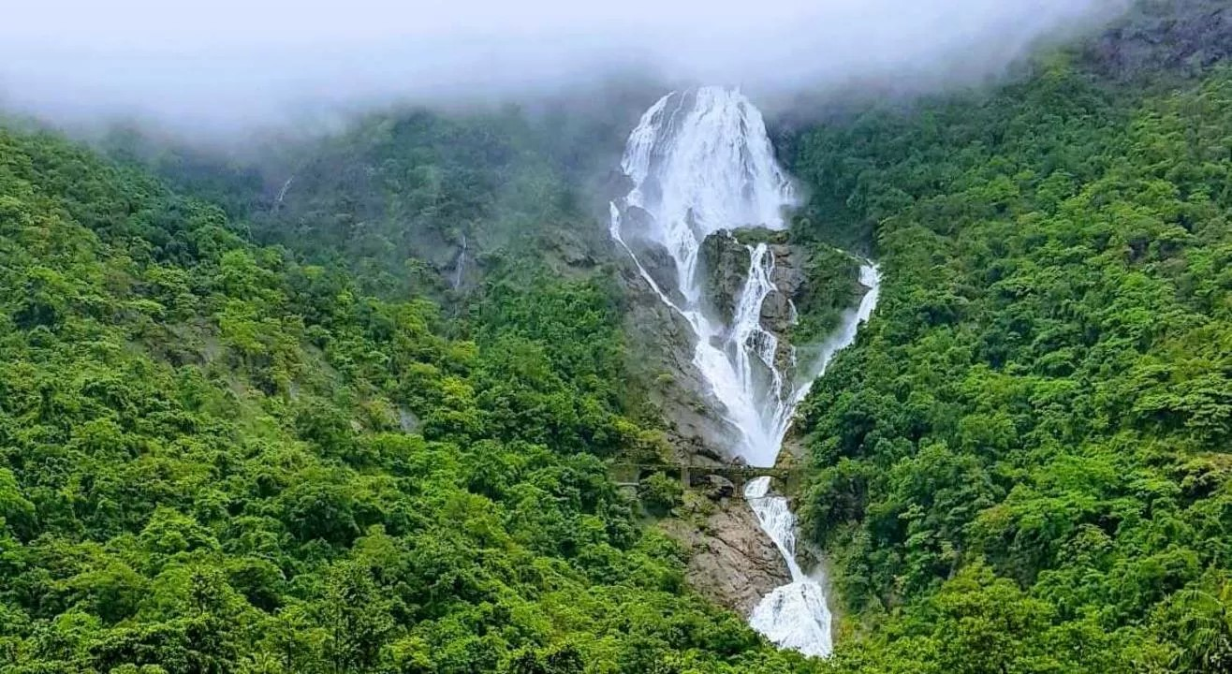

# Baga Beach

One of the most popular beaches in North Goa, Baga Beach is located close to Calangute beach, around 30 Km North of Panjim. Baga is the perfect destination to witness the dazzling nightlife of Goa as signature places such as Britto's, Tito's and Mambos are located in the vicinity. Being one of the most visited beaches in the North, Baga also offers a vast range of water sports.

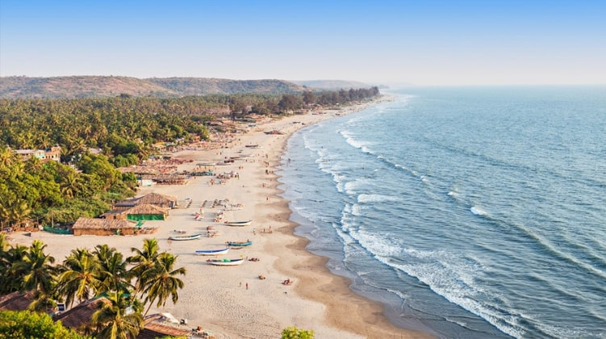

# Anjuna Beach

Located near Panjim at a distance of 21 km, Anjuna Beach is among the most popular beaches in North Goa, stretching almost 2km. A hippie paradise of sorts it is characterized by its rocky outcrops. From family outings to adrenaline-filled adventures, Anjuna Beach is famed for its golden coastline, nightclubs, beach shacks, watersports, full-moon parties and flea markets.

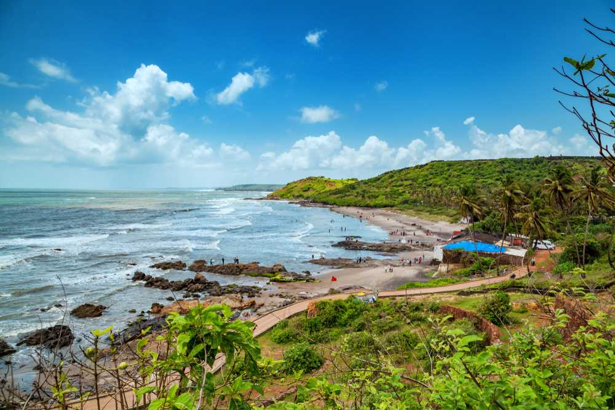

**12. Agra**

# Taj Mahal

One of the seven wonders of the world, Taj Mahal is located on the banks of River Yamuna in [Agra](https://www.holidify.com/places/agra). It was built by the Mughal Emperor Shah Jahan as a memorial for his third wife, Mumtaz Mahal. It also houses the tomb of Shah Jahan himself. Constructed entirely out of white marble in the 17th century, Taj Mahal is one of the most beautiful monuments in the world. Every year visitors numbering more than the entire population of Agra pass through the magnificent gates to catch a glimpse of this breathtaking monument!

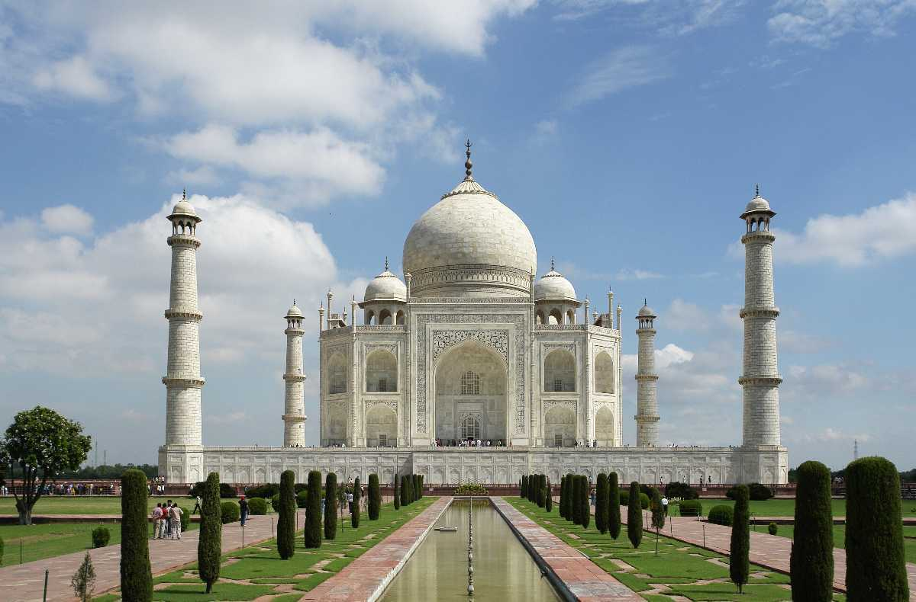

# Agra Fort

An architectural masterpiece, The Red Fort of Agra or Agra Fort was built by Emperor Akbar in 1573. It is located on the right bank of the River Yamuna and is made entirely of red sandstone. The historical fort was once the ersthwhile residence of the Mughals until 1638. One of the UNESCO World Heritage Sites, it lies 2.5 kilometres from [Taj Mahal](https://www.holidify.com/places/agra/taj-mahal-sightseeing-1020.html).

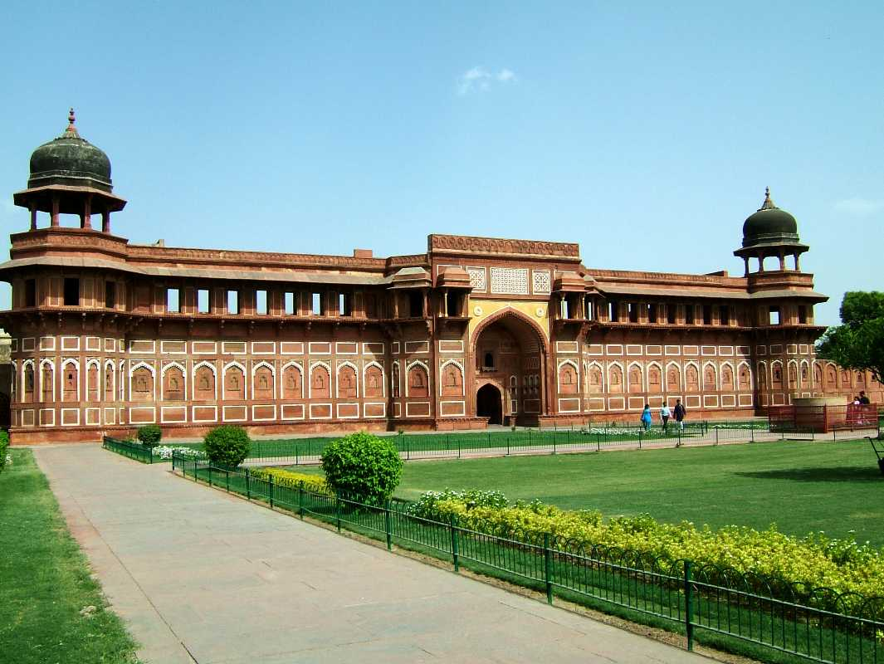

# Dolphin Water Park

Inaugurated in 2002, Dolphin World Water Park is spread over an area of 14 acres and is replete with thrilling slides, roller coasters, water and regular rides etc. Besides, it has an amusement park, a play area for kids, a locker room and other facilities. Dolphin Water World has been a popular source of recreation and entertainment for the city dwellers and tourists ever since. The water cum theme park offers a variety of rides and fun games both for adults and kids, They also have height based separate swimming pools.

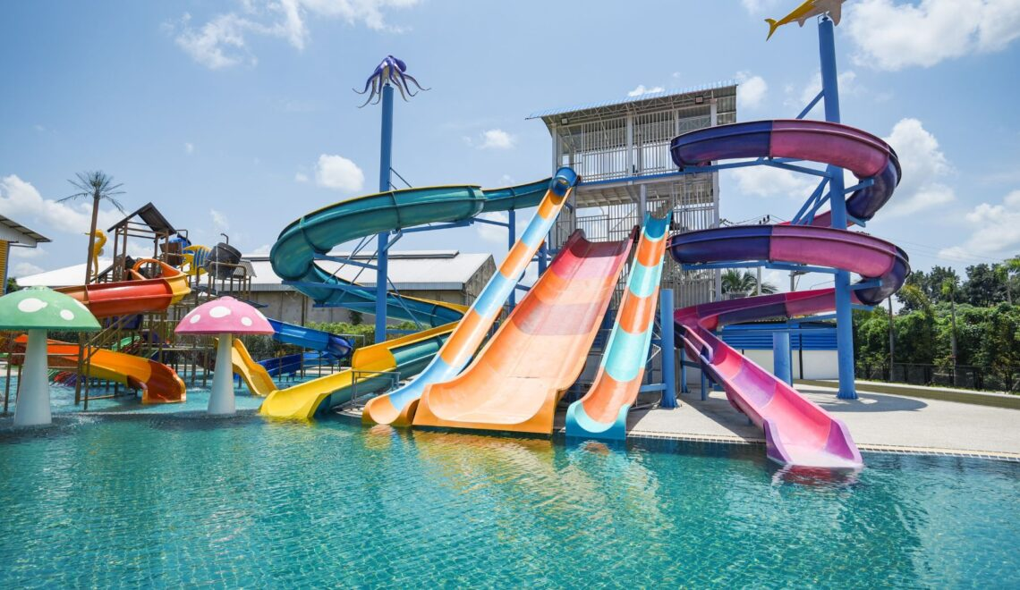

**13. Vrindavan**

# Prem Mandir

Imbued with elegance and grandeur, the Prem Mandir is a massive temple that was shaped by Jagadguru Shri Kripaluji Maharaj in the year 2001. Known as "Temple of God's love", this grand religious place is dedicated to Radha Krishna as well as Sita Ram. Located in Vrindavan, the holy city in the district of Mathura in Uttar Pradesh, the temple is enveloped with piousness and serenity. This newly constructed temple is the most beautiful in the entire Brij area and is crowded with devotees during the time of the Aarti.Read More

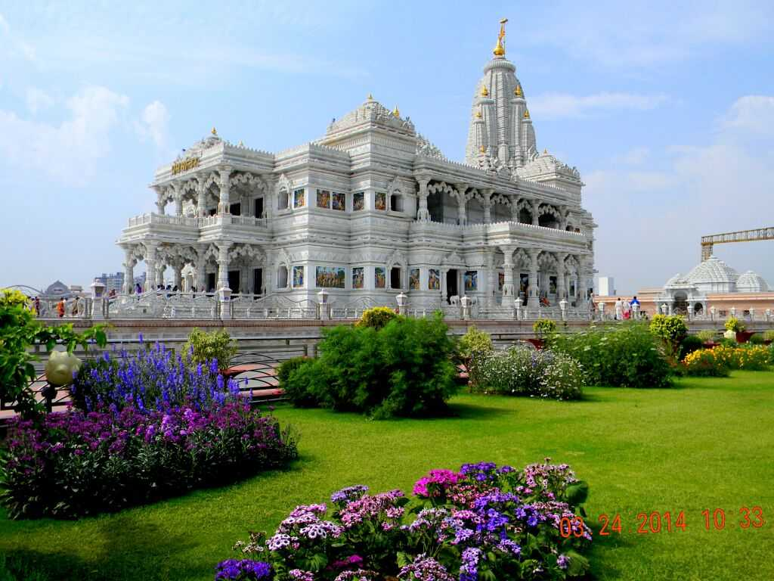

# Banke Bihari Mandir

Shri Banke Bihari Mandir is a Hindu temple dedicated to Lord Krishna in the holy city of [Vrindavan](https://www.holidify.com/places/vrindavan) in the [Mathura](https://www.holidify.com/places/mathura) district. One of the most revered shrines in the country, this temple is among the 7 temples of Thakur of Vrindavan which also include Sri Radhavallabh Ji, Shri Govind Dev Ji and four others. As you come in the presence of the Banke Bihari Temple, you are confronted with the stunning Rajasthani- style edifice of the temple, which is adorned with arched windows and meticulous stonework. The image of Lord Krishna in the temple appears in the form of a child and is seen standing in the Tribhanga position. One interesting fact about the Banke Bihari temple is that there are no bells or conchs in the premises, as the Lord does not like the sound of these instruments. Divine invocations are performed by peaceful chants of 'Radha Naam'.

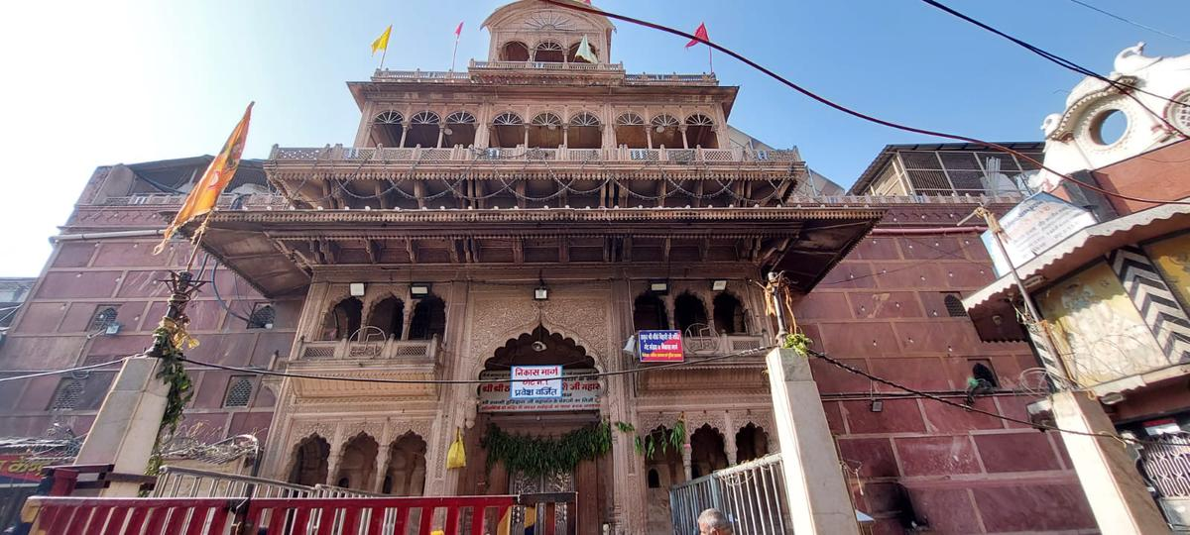

## **Sri Govind Devji Temple, Vrindavan.**

Sitting on the laps of the very town where the Hindu God, Lord Krishna is believed to have spent his childhood, the Govind Devji Temple stands as an architectural marvel since the past five centuries. The temple, built of red sandstone, is dedicated to Lord Krishna in his childhood home. Vrindavan is a twin town to Mathura, where Sri Krishna was born and adjacent to Gokul, where he is believed to have spent the initial years of his childhood.

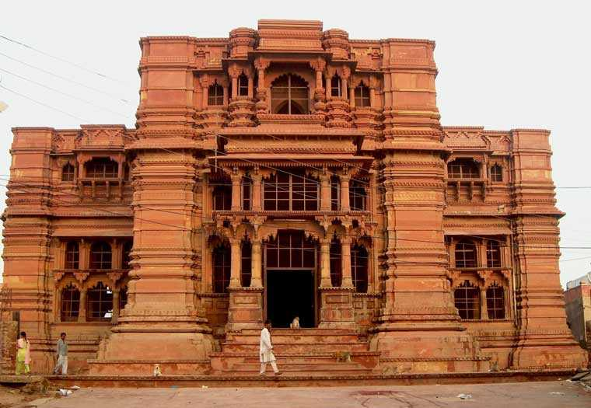

**14. PURI**

## **Raghurajpur Artist Village**

In 2000, Raghurajpur was honored as a 'heritage village' by the Indian National Trust for Art and Cultural Heritage (INTACH), fostering a renaissance of traditional art forms among its artisans. Both men and women actively engage in this artistic pursuit. These artisans warmly welcome visitors, readily sharing insights into the art's origins and techniques. Many families graciously open their homes to guests, offering direct purchases of their creations. For a deeper experience, visitors can even partake in lessons offered by the artisans for a separate fee. As you explore this vibrant artistic haven, take a moment to honor the legacy of Guru Kelucharan Mohapatra, a celebrated luminary of Odissi dance whose roots trace back to Raghurajpur.

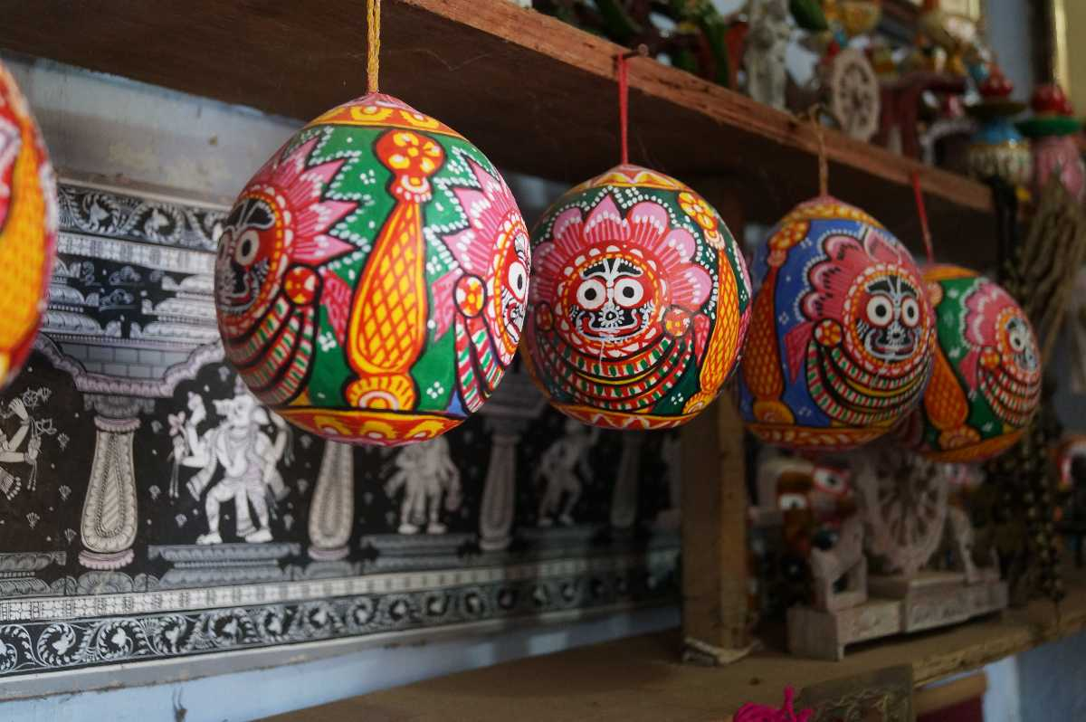

## **Puri Beach**

Puri Beach is one of the finest coastlines in East India, bordering the Bay of Bengal and is located at a distance of 35 km from the Sun Temple. With the sun gleaming on the pristine waters of the beach, the place is ideal for holiday makers looking for some solitude. It is often flocked by devotees visiting the beach for a purification dip who come to Puri to pay their homage to Lord Jagannath. The beach is also renowned for the sand sculptures made by internationally known sand artist Sudarshan Patnaik. The sculptures are usually inspired by the art covering the temple walls or other mythological character or episode.

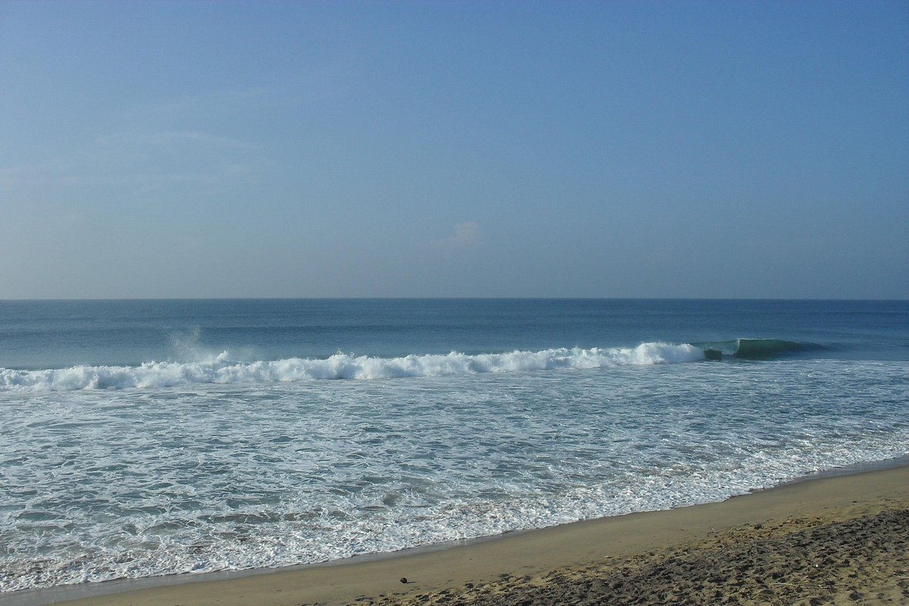

## **Ganesh Temple,**

Inside the famous Jagannath temple complex in Puri, is situated a small Ganesh temple, housing an exclusive image of Ganesh known as Natya Ganesh i.e. Dancing Ganesh.

Inside the famous Jagannath temple complex in Puri, is situated a small Ganesh temple, consisting of an exclusive image of Ganesha known as Natya Ganesh i.e. Dancing Ganesh. The temple has great archaeological significance. In spite of its small size, every year large number of devotees offer their prayers. History reveals that the idol is gifted by the King of Kanchi. The Jagannath temple complex comprises of many other temples dedicated to gods Hanuman, Surya, Saraswati, Vimala. In front of the Ganesh temple, a small water-pot built up of stones known as Rohinikund is also present.

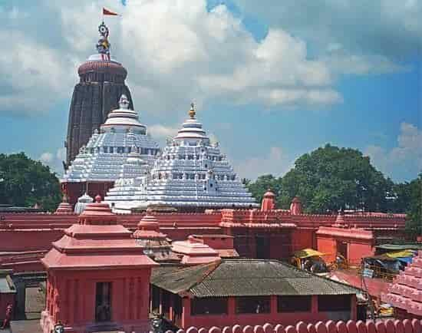

**15. MUNNAR**

# Echo Point, Munnar

# Located at an altitude of 600 ft. and at a distance of about 15 kilometres from Munnar, Echo Point is situated right in the lap of a quaint lake and misty hills covered with lush green trees. As the name suggests, this place is well known for its enthralling illustration of the phenomenon of echoing. As you scream, it is fun to hear your voice reverberate around the attraction

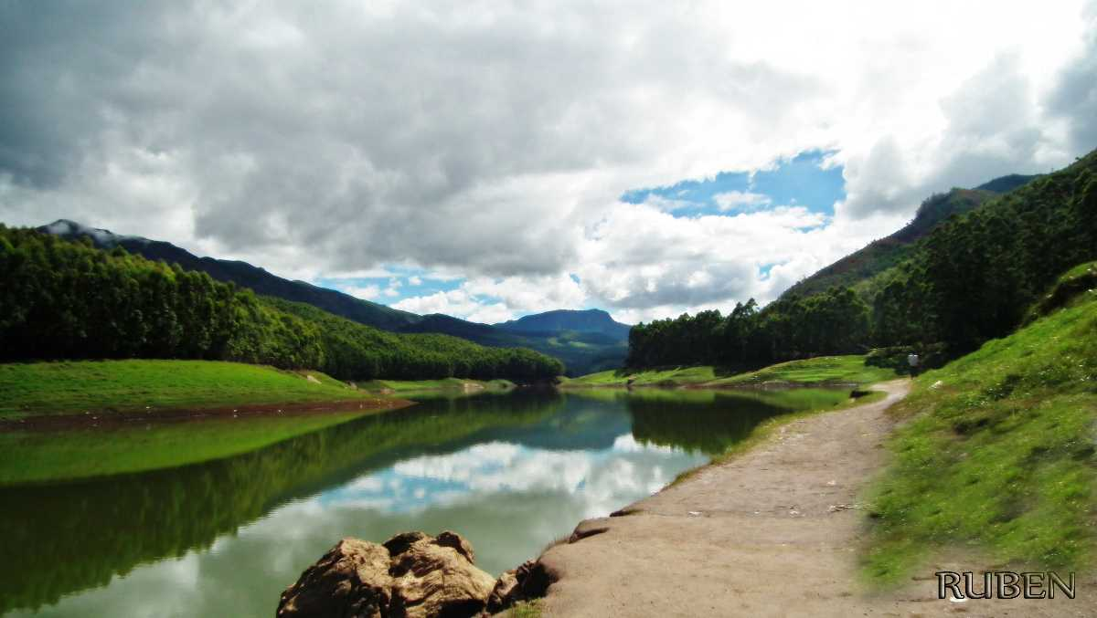

## **Eravikulam National Park, Munnar Overview**

Located a 45 - minute drive away from Munnar, the Eravikulam National Park (also known as Rajamalai Wildlife Sanctuary), houses a rich and diverse variety of flora and fauna and is a UNESCO world heritage site. Elephant, Nilgiri langur, Nilgiri marten, Atlas moth (largest in the world), lion-tailed macaque, small-clawed otter, and a rare tiger or leopard are some of the main animal species that can be spotted here

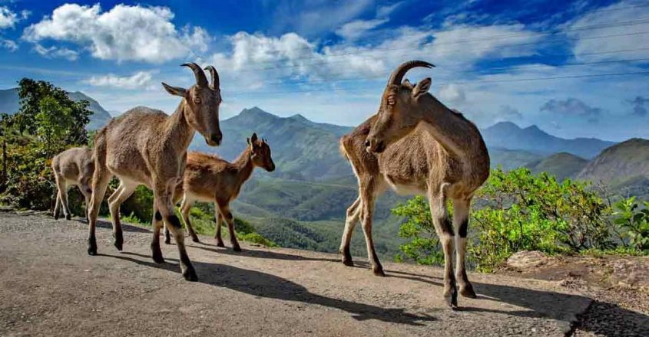

## **Trekking in Munnar, Munnar Overview**

Perched atop the undulating peaks of the great range of Sahyadri, a World Heritage Site declared by UNESCO, Munnar is a mesmerising hill station in Kerala that offers a plethora of trekking trails for the trekkers to explore. The whole range is covered with carpets of greenery, low slopes covered with some of the world's highest tea plantations and rainforests rich in biodiversity, endemics and spice plantations and hills with their crests hidden behind a blanket of fog along with stretches of rugged terrains

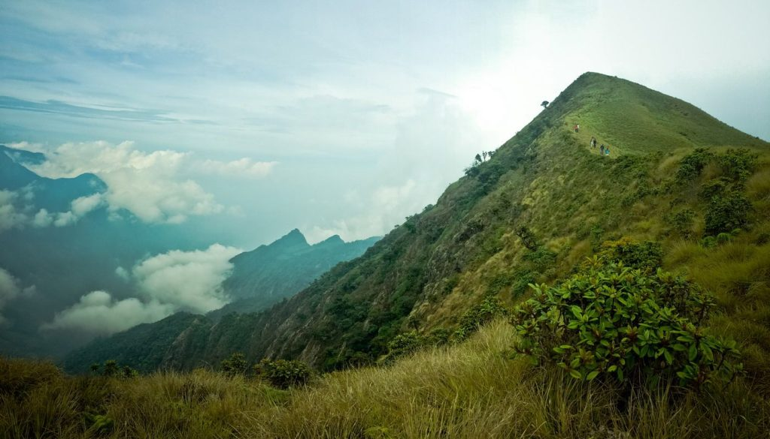

**16.Manali**

# Hidimba Temple

Located amidst the snow-covered hills of Manali, the Hadimba Temple is a unique shrine dedicated to Hidimba Devi, who was the wife of Bhima and mother of Ghatothkach. Surrounded by gorgeous cedar forests, this beautiful shrine is built on a rock which is believed to be in the image of goddess Hidimba herself. Locally known as Dhungari Temple, the construction style of the Hidimba Devi temple is entirely different from that of any of the other temples, with its wooden doorways, walls, and cone-shaped roof. This temple is a fitting dedication to its presiding deity Hadimba.

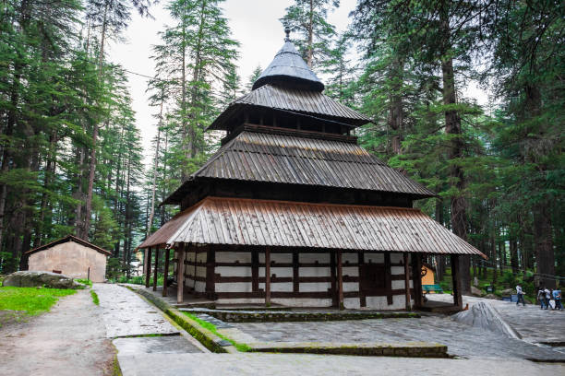

## **Paragliding in Kullu Manali, Manali Overview**

The hillside town of Manali is famous for paragliding. At 2050 metres above sea level, it is an ultimate location for the sport, with its beautiful green valleys, stark blue skies, and snow-capped mountain peaks.

The picture-perfect valley boasts of ideal wind conditions for paragliding and is thronged by both international and domestic tourists. Starting with a basic training course, the operators are well organized, competent and trustworthy.

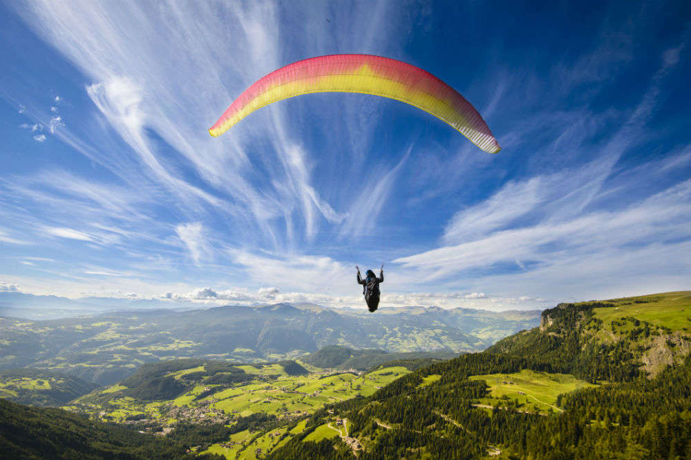

## **Solang Valley, Manali Overview**

When heading to [Manali](https://www.holidify.com/places/manali) for a vacation, two absolutely essential destinations in the itinerary are [Rohtang](https://www.holidify.com/places/manali/rohtang-pass-sightseeing-2765.html) and Solang Valley. 14 kilometres to the north west of the main town of Manali, Solang Valley is one of the most popular tourist destinations in Himachal Pradesh. Situated on the way to Rohtang from Manali, every year the valley welcomes tourists in huge numbers. A favourite for adventure enthusiasts, parachuting to paragliding, horse riding to driving mini-open jeeps specially available for tourists of all age groups, Solang Valley has it all

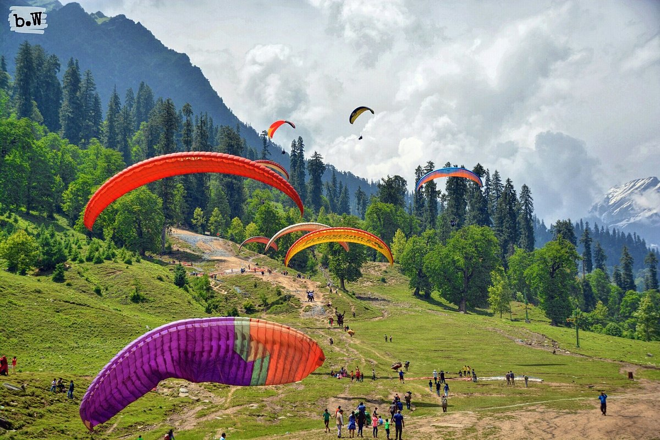

## **17. SHIMLA**

## **Kalka Shimla Toy Train**

The Kalka to Shimla route is best travelled by way of the toy train that runs on a narrow-gauge track and is known for its dramatic views of the hills and surrounding villages. The historic Kalka Shimla Toy train is part of the UNESCO World Heritage List and takes individuals on a ride amongst vast green hills and deodar and pine forests.

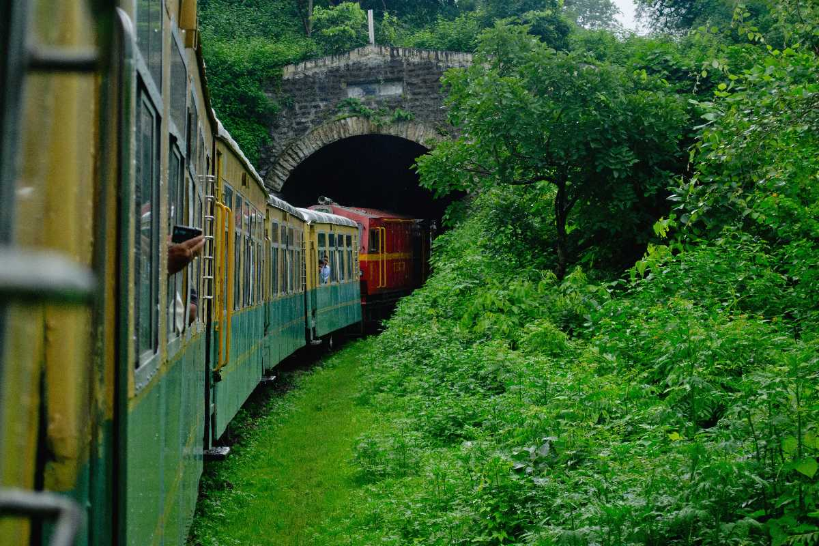

## **Christ Church, Shimla Overview**

Known as the second oldest church in North India, the Christ Church is inspired by the  neo-gothic style of architecture and is complete with a front porch, church bells and five stained glass windows that represent different virtues of Christianity. The church, which took 11 long years to complete, stands as a reminder of the British colonisation in India.

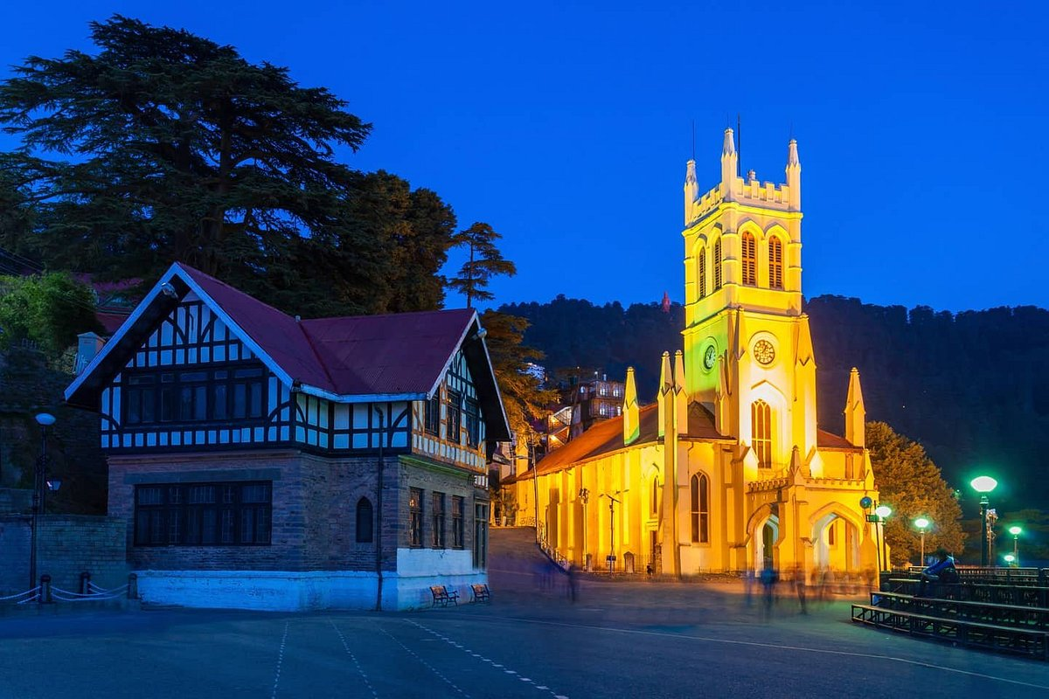

## **Jakhoo Temple, Shimla Overview**

Set amidst the lush green background of the Shivalik hill ranges, the highest point in Shimla, the Jakhu Temple is an ancient site dedicated to the Hindu god - Hanuman. Jakhu Temple has the world's largest Hanuman statue, which is visible from most parts of Shimla. Overlooking the sister town of Sanjauli, the amazing setting of Jakhoo Temple in the thick of beautiful Deodar trees is complemented with an abundant monkey population in and around the Jakhoo Hill area.

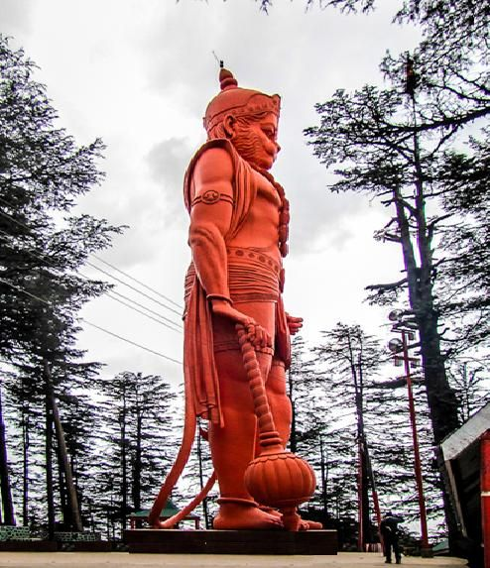

**18. GOKARNA**

## **Mahabaleshwara Temple, Gokarna Overview**

A 6 feet tall Shiva Linga here at the temple is known as the Atmalinga is worshipped here. Built using white granite, it is a classic example of the beauty of Dravidian architecture. A 1500 years old carved stone Lord Shiva idol in the standing position represents the main deity. The temple has been mentioned in the Hindu Mythics of Mahabharata and Ramayana and it is said to be as significant as Kashi, hence it earning the title, Dakshin (South) Kashi.

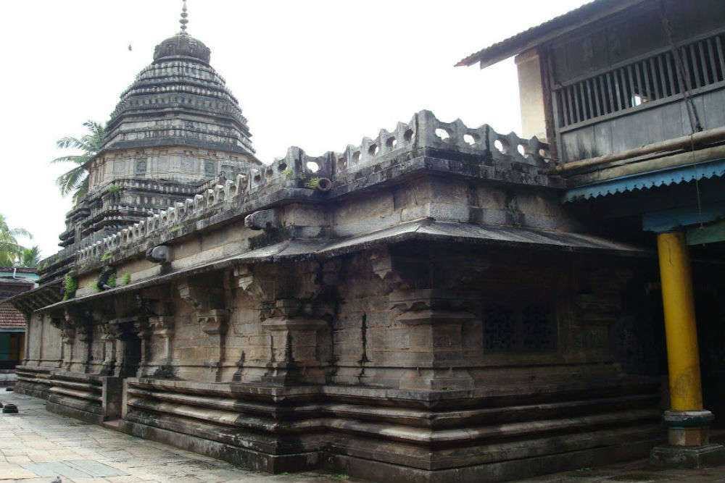

## **Om Beach, Gokarna Overview**

Om beach is a wonderful beach located in the town of [Gokarna](https://www.holidify.com/places/gokarna). Shaped like the symbol 'Om', this beach offers plenty of adventure sports to the thrill-seekers. The view of this beach during sunset is one to be cherished forever. It is usually lined with shacks on the sides offering cheap accommodation and restaurants with global menus. There is also a bunch of fun water sports activities available on Om Beach, including speedboats, surfing etc. Visitors can even enjoy boating here.

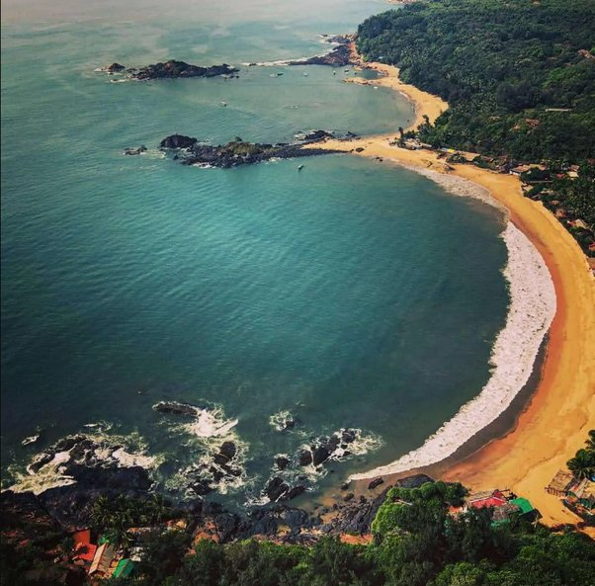

## **Mirjan Fort, Kumta Overview**

Located on the banks of River Aghanashini, Mirjan Fort is a royal reminder of our glorious history. It is situated about 11 km from the town of Kumta in Karnataka and is spread over an area of 4.1 hectares. The fort is also believed to be a site for many past battles in 16th and 17th Century and was functional till 1785. Later, the British captured this fort and used it for their armoury. It is embellished with remarkable architecture of the bygone era, such as canals, moats, secret passageways and various other considerations to fortify its grounds. The splendid fort truly gives the impression of a fairytale castle all covered with grass and overgrowth.

